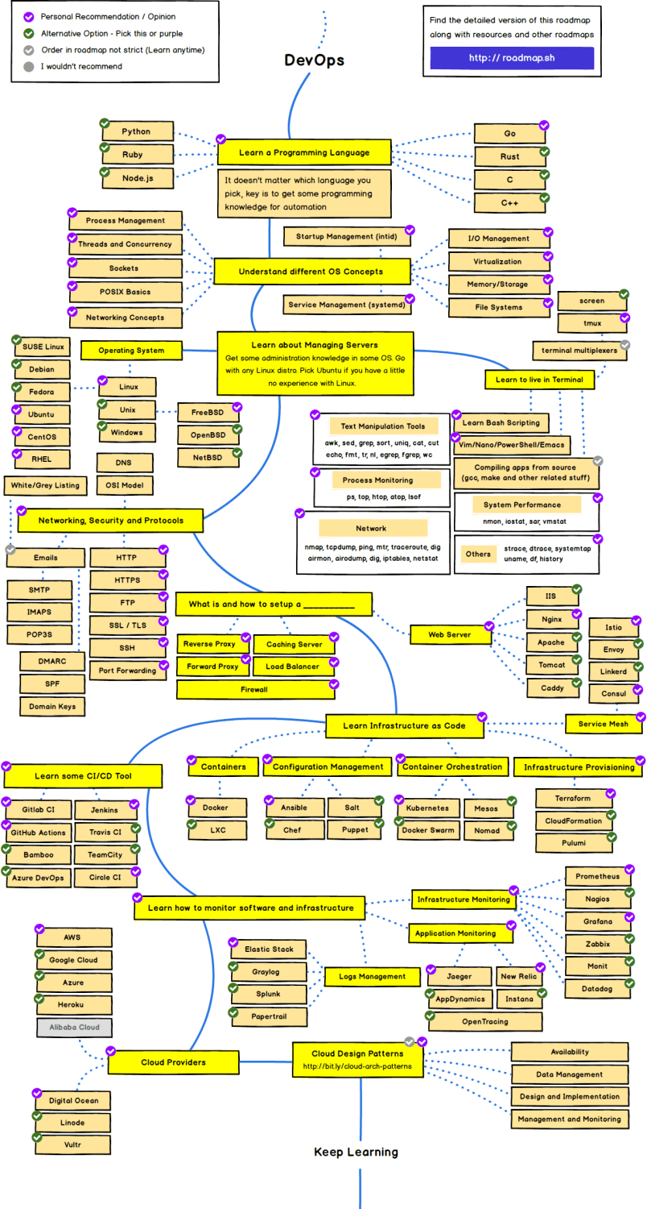

**COSAS POR HACER:**

1. Aprender un lenguaje de programación:

* Curso de GO
  + <https://www.youtube.com/watch?v=YS4e4q9oBaU>
* Curso de Python
  + <https://www.youtube.com/watch?v=_uQrJ0TkZlc>
  + <https://www.youtube.com/watch?v=rfscVS0vtbw>
  + <https://www.youtube.com/watch?v=WGJJIrtnfpk>

1. Entender Diferentes OS

* <https://www.youtube.com/watch?v=Snrh580U3tI>
* <https://www.youtube.com/watch?v=mXw9ruZaxzQ>

1. Aprender acerca de administración de servidores

* <https://www.youtube.com/watch?v=wsh64rjnRas>
* <https://www.youtube.com/watch?v=v_1zB2WNN14>
* Ngnix: <https://www.youtube.com/watch?v=lWjZSgXu5VU>

1. Networking, seguridad y protocolos

* <https://www.youtube.com/watch?v=QKfk7YFILws>
* <https://www.youtube.com/watch?v=U_P23SqJaDc>

1. Aprender Infraestructura as Code

* Docker: <https://www.youtube.com/watch?v=RSIstPUiEjY>
* Kubernetes: <https://www.youtube.com/watch?v=Mi3Lx7yk3Hg>
* Ansible: <https://www.youtube.com/watch?v=EcnqJbxBcM0>
* Chef: <https://www.youtube.com/watch?v=LTIjUJEehDA>
* Salt: <https://www.youtube.com/watch?v=XovHdJZp1X4&list=PLgGQIE0cGrkiDRmJ3YWBKlI2KuYfFvfzV>
* Puppet: <https://www.youtube.com/watch?v=kHD4KQKKP5Y>
* Terraform: <https://www.youtube.com/watch?v=0-z1G0BFZSU>
* Cloud Formation: <https://www.youtube.com/watch?v=0-z1G0BFZSU>

1. Aprender CI/CD

* Jenkins: <https://www.youtube.com/watch?v=FX322RVNGj4>
* Github: <https://www.youtube.com/watch?v=3FKrszHcIsA>

1. Aprender de monitoreo de software e infraestructura

* Nagios: <https://www.youtube.com/watch?v=knCO6wzCW3w>
* Prometheus: <https://www.youtube.com/watch?v=9GMWvFcQjYI>
* Grafana: <https://www.youtube.com/watch?v=sTP7yzXmdFk&list=PLyJqGMYm0vnO9osZ-EBV6iu2l10muE2A->

1. Proveedores Cloud

* Curso AWS:
  + <https://www.youtube.com/watch?v=RrKRN9zRBWs>
  + <https://www.youtube.com/watch?v=PxGGeNEdb3E>
  + <https://www.youtube.com/watch?v=k1RI5locZE4>

MAPA INTERACTIVO DE DEVOPS: <https://infinite.education/expertise/linux_administrator>

Por revisar:

Gradle, Maven

JUnit,TestNG, Selenium